Installation Qualification (IQ)
By approving this document, you confirm that you have completed training on BTSQC09.05 and agree with the contents of this document.
Document Prepared/Reviewed By:
Name and Function | Signature | Date
Kateryna Novodvorska, Author | Captured electronically | Captured electronically

Document Pre-Approvals:
Name and Function | Signature | Date (DD-MON-YYYY)
Gopalan Kannan, ADC Architect | Captured electronically | Captured electronically
Madeline Halliday, SQA | Captured electronically | Captured electronically

Revision History
Document Version # | Revision Date  (DD-MON-YYYY) | Author | Change Request  Number | Change Summary  (Reference section[s] changed)
1.0 | 15-JUL-2025 | Kateryna Novodvorska | COM-25-00478 | Initial writing

OVERVIEW

Purpose
This document provides instructions for the installation and qualification of Sales Assist Veeva CRM, software version (production) 251.2.301. Acceptance criteria are included to confirm that the hardware and software are installed in accordance with manufacturer guidelines, Abbott BTS specifications and to assure that the installation is qualified.
These installation instructions are developed for the experienced installer.

Scope
This document covers the installation and qualification of the following hardware and software components:
- The software components leverage standard SFDC Platform to install and build components against Abbott business and functional requirements for Sales Assist Veeva CRM Enhancements.
- Test Cases not required for this release will be marked as Not Applicable.
- Hardware Component / Version # N/A.
- Sales Assist does not involve installation of Hardware Components.

References
This document references the following documents:
- [COM-25-00478] SalesAssist Veeva CRM - Software Maintenance Release from MAY 2025 to OCT 2025
- [COM-25-00478-P-003] SalesAssist Veeva CRM - CIA 002

Terms and Abbreviations

Reference Abbott Glossary.
Term / Acronym | Definition
IQ | Installation Qualification
OQ | Operational Qualification

INDEX OF INSTALLATION TEST CASES
Test Case ID | Test Case Objectives
IQ-001Case 1 | Hardware / Software Verification – verify minimum hardware and software requirements.
IQ-002 Case 2 | Vendor Package Deployment: Vendor Version upgrade deployed by Veeva
IQ-003 Case 3 | Software Qualification
IQ-004 Case 4 | Software Configuration/Modification

ACCEPTANCE CRITERIA
The execution of this Installation Qualification is accepted if the following conditions are met:
- All steps were executed successfully and supporting artifacts are retained as appropriate.
- Any associated discrepancies have been addressed and resolved.

CASE 1 - HARDWARE / SOFTWARE VERIFICATION
Test Case ID: |  | IQ-001 |  |  |  | Version: |  |  | N/A
Test Case Type: |  | N/A |  |  |  | Run Number: |  |  | N/A
Environment |  | N/A |  |  |  | Installer |  |  | N/A
Objective / Description: |  | N/A
Pre-Requisites: |  | Topic: | N/A
Item |  | Parameter | Requirement | Actual |  |  | Pass / Fail |  |  |  |  |  | Comments
Hardware |  | Processor | N/A | N/A |  |  | ☐ | Pass | ☐ |  | Fail |  | N/A
 |  | Memory | N/A | N/A |  |  | ☐ | Pass | ☐ |  | Fail |  | N/A
 |  | Disk Space | N/A | N/A |  |  | ☐ | Pass | ☐ |  | Fail |  | N/A
Software |  | Operating System | N/A | N/A |  |  | ☐ | Pass | ☐ |  | Fail |  | N/A
 |  | Application Software and Version | N/A | N/A |  |  | ☐ | Pass | ☐ |  | Fail |  | N/A
 |  | Support Software | N/A | N/A |  |  | ☐ | Pass | ☐ |  | Fail |  | N/A
 |  | Verify Software components match the approved Change documentation. | N/A | N/A |  |  | ☐ | Pass | ☐ |  | Fail |  | N/A
Other |  | Reporting Tools | N/A | N/A |  |  | ☐ | Pass | ☐ |  | Fail |  | N/A
 |  | Interfaces | N/A | N/A |  |  | ☐ | Pass | ☐ |  | Fail |  | N/A
RESULTS
Do install components satisfy system needs and expectations? |  |  |  |  |  |  |  |  | ☐ |  |  | Yes |  | ☐ | No
I have executed these instructions and have appropriately documented the results of the execution and written/referenced Test Defect Reports when needed.
Executed by: | N/A |  |  |  | Date: |  |  |  |  | N/A

CASE 2 – VENDOR VERSION UPGRADE DEPLOYMENT
Test Case ID: |  | IQ-002 |  |  |  | Version: |  |  | N/A
Test Case Type: |  | N/A |  |  |  | Run Number: |  |  | N/A
Environment |  | N/A |  |  |  | Installer |  |  | N/A
Objective / Description: |  | N/A
Pre-Requisites: |  | Topic: |  | N/A
Step | Instruction |  |  |  |  |  | Pass / Fail |  |  |  |  |  |  |  | Comments
1. | N/A |  |  |  |  |  | ☐ | Pass |  |  | ☐ |  | Fail |  | N/A
RESULTS
Does software installation satisfy computer system needs and expectations? |  |  |  |  |  |  |  |  |  | ☐ |  |  |  | Yes |  | ☐ | No
I have executed these instructions and have appropriately documented the results of the execution and written/referenced Test Defect Reports when needed.
Executed By: |  |  | N/A |  | Date: |  |  |  |  |  |  | N/A

CASE 3 – SOFTWARE QUALIFICATION
Test Case ID: |  | IQ-003 |  |  |  | Version: |  |  | N/A
Test Case Type: |  | N/A |  |  |  | Run Number: |  |  | N/A
Environment |  | N/A |  |  |  | Installer |  |  | N/A
Objective / Description: |  | N/A
Pre-Requisites: |  | Topic: |  | N/A
Step | Qualification |  |  |  |  |  | Pass / Fail |  |  |  |  |  |  |  | Comments
1. | N/A |  |  |  |  |  | ☐ | Pass |  |  | ☐ |  | Fail |  | N/A
RESULTS
Does software installation satisfy computer system needs and expectations? |  |  |  |  |  |  |  |  |  | ☐ |  |  |  | Yes |  | ☐ | No
I have executed these instructions and have appropriately documented the results of the execution and written/referenced Test Defect Reports when needed.
Executed By: |  |  | N/A |  | Date: |  |  |  |  |  |  | N/A

CASE 4 – SOFTWARE MODIFICATION
Test Case ID: |  | IQ-004 |  |  |  | Version: |  |  | 1
Test Case Type: |  | Installation |  |  |  | Run Number: |  |  | 1
Environment |  | ☒ QA ☐ Production |  |  |  | Installer |  |  | Corinne Nagle - Veeva
Objective / Description: |  | Configure the Sales Assist Veeva CRM App and CRM
Pre-Requisites: |  | Topic: |  | The QA environment must be configured for the deployment as per [COM-25-00478-P-003] SalesAssist Veeva CRM - CIA 002
Step | Qualification |  |  |  |  |  | Pass / Fail |  |  |  |  |  |  |  | Comments
1 | New apex class - VPRO_HCPEligibility_Service should be created (which queries lot of objects and identify the Sample Eligibility and other fields) |  |  |  |  |  | ☒ | Pass |  |  | ☐ |  | Fail |  | N/A
2 | New custom metadata - NCO_HCP_Sample_Eligibility__mdt should be created |  |  |  |  |  | ☒ | Pass |  |  | ☐ |  | Fail |  | N/A
3 | New custom field ADC_Sample_Eligibillity__c on NCO_HCP_Sample_Eligibility__mdt should be created with values as –  {"ADC_Subtype__c":["Prescriber"],  "NET_Account_Status__c":["Active"],  "Credentials_vod__c":["MD","DO","NP","PA"],  "ADC_Target_Type__c": ["TIER 1", "TIER 2", "TIER 3", "NON-TARGET", "DSS NT AFFILIATE", "DSA NT AFFILIATE"],  "ADC_Approved_Specialty__c":"true",  ADC_Veeva_GOV__c = false  Is_Veeva_Mastered__c = true  ADC_Gov__c = false  "ADC_AMA_Do_Not_Contact__c":"false",  "Sensor_Kit_Sample_Limit__c":"true",  "ADC_Primary_State__c":["GA", "AL", "AK", "AZ", "AR", "CA", "CO", "CT", "DE", "FL", "HI", "IA", "ID", "IL", "IN", "KS", "KY", "LA", "ME", "MD", "MA", "MI", "MN", "MS", "MO", "MT", "NE", "NV", "NH", "NJ", "NM", "NY", "NC", "ND", "OH", "OK", "OR", "PA", "RI", "SC", "SD", "TN", "TX", "UT", "VT", "VA", "WA", "WV", "WI", "WY", "DC", "PR"]} |  |  |  |  |  | ☒ | Pass |  |  | ☐ |  | Fail |  | Step #3 was revised in this [COM-25-00478-P-007-EX-01] SalesAssist Veeva CRM - Installation Qualification - CIA 002 to modify the data pull originally documented in the pre-approved [COM-25-00478-P-007] SalesAssist Veeva CRM - Installation Qualification - CIA 002.
4 | New custom field Sample_Limit_Criteria__c on NCO_HCP_Sample_Eligibility__mdt should be created with values as –  {"Current_Year__c":"true"} |  |  |  |  |  | ☒ | Pass |  |  | ☐ |  | Fail |  | N/A
5. | New custom field ADC_Account_Fields__c on NCO_HCP_Sample_Eligibility__mdt should be created with values as -  FirstName,LastName, Credentials_vod__c,PersonEmail,Network_email_1__c,  ADC_eSampling_Email__c,Phone,Role__c,ADC_Gov__c |  |  |  |  |  | ☒ | Pass |  |  | ☐ |  | Fail |  | N/A
6. | New custom field ADC_Address_fields__c on NCO_HCP_Sample_Eligibility__mdt should be created with values as –  Network_External_ID__c, Name, Address_line_2_vod__c, City_vod__c, State_vod__c,Zip_vod__c,  NET_Address_Ordinal__c,Phone_vod__c |  |  |  |  |  | ☒ | Pass |  |  | ☐ |  | Fail |  | N/A
RESULTS
Does software installation satisfy computer system needs and expectations? |  |  |  |  |  |  |  |  |  | ☒ |  |  |  | Yes |  | ☐ | No
I have executed these instructions and have appropriately documented the results of the execution and written/referenced Test Defect Reports when needed.
Executed By: |  |  | Corinne Nagle |  | Date: |  |  |  |  |  |  | 18-JUL-2025

OBJECTIVE EVIDENCE
Installer: Corinne Nagle – Veeva

Test Case IQ-004:

Steps 1-6 were deployed via the package deployment

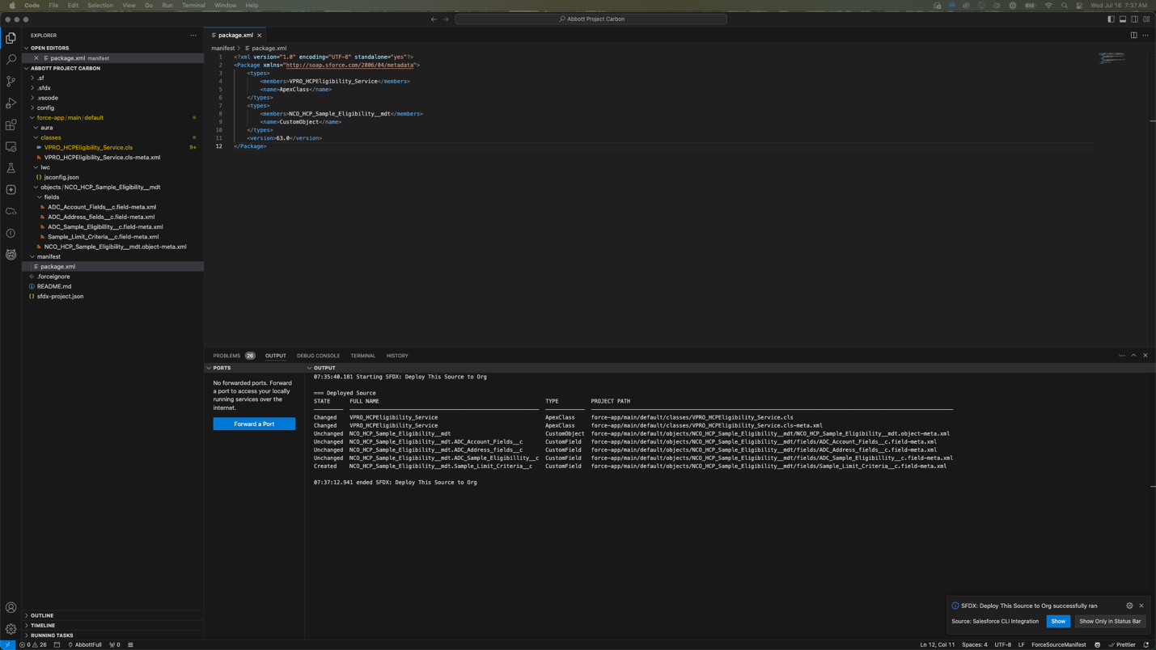
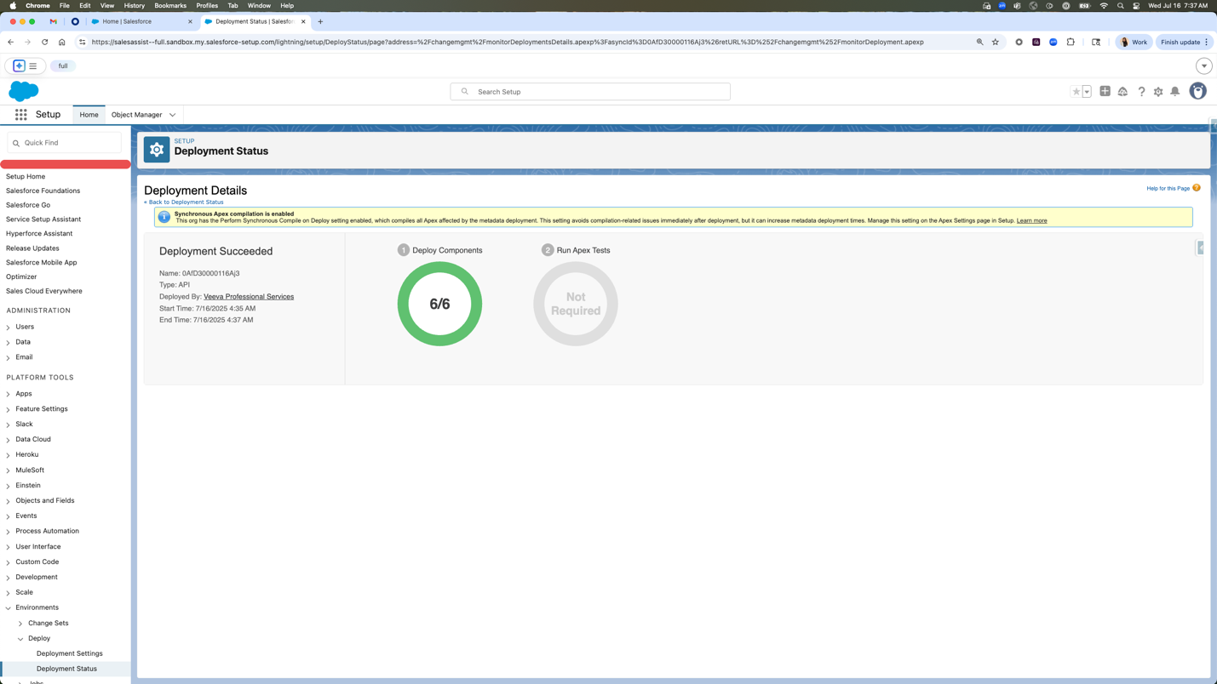
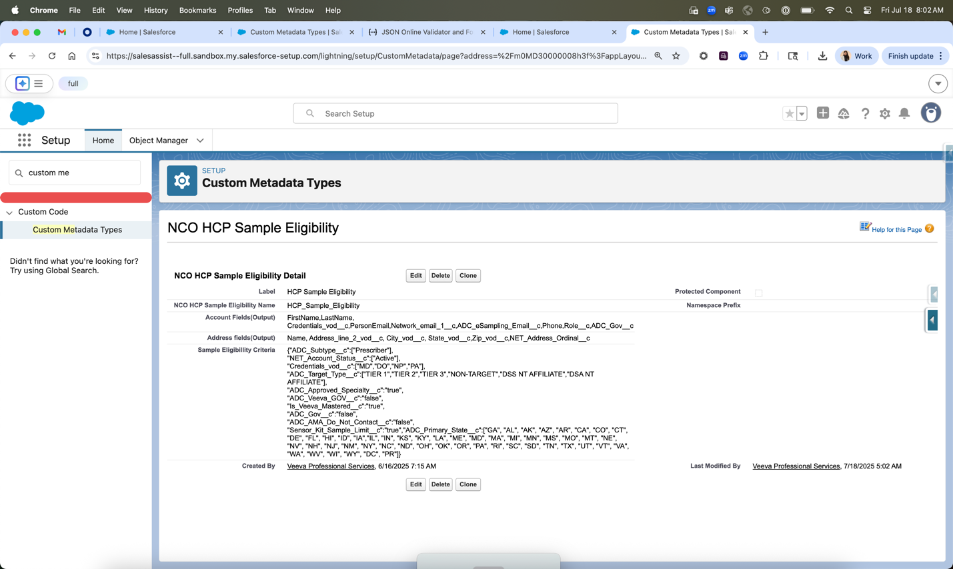

EXECUTION SUMMARY
Execution Summary
Q1- Was the IQ executed without any discrepancy or protocol errors? |  |  |  | ☒ | Yes | ☐ | No
Q2- If the discrepancy or protocol error occurred, IQ update is needed? |  |  |  | ☐ | Yes | ☒ | No
Test Case# | Step# | Tester Comments |  | Note/Resolution
IQ-004 | 1-6 | All steps were executed and passed successfully. |  | N/A
IQ-004 | 3 | Revision to step #3 |  | Step #3 was revised in this [COM-25-00478-P-007-EX-01] SalesAssist Veeva CRM - Installation Qualification - CIA 002 to modify the data pull originally documented in the pre-approved [COM-25-00478-P-007] SalesAssist Veeva CRM - Installation Qualification - CIA 002. This step was deployed to the QA environment as part of the package deployment.
Executed by: Corinne Nagle |  |  | Date: 18-JUL-2025

Reviewer Comments☐ N/A
Step #3 was revised in this [COM-25-00478-P-007-EX-01] SalesAssist Veeva CRM - Installation Qualification - CIA 002 to modify the data pull originally documented in the pre-approved [COM-25-00478-P-007] SalesAssist Veeva CRM - Installation Qualification - CIA 002. This step was deployed to the QA environment as part of the package deployment.
Reviewed by: Gopalan Kannan Date: 18-JUL-2025

Execution Post-Approvals:
Name and Function | Signature | Date (DD-MON-YYYY)
Gopalan Kannan, Architect | Captured electronically | Captured electronically
Madeline Halliday, SQA | Captured electronically | Captured electronically
Corinne Nagle, Installer/Technical Representative | Captured electronically | Captured electronically
END OF document

